**Sending light illuminance data to Nodered using Nodemcu**

**Setting up the Nodered Flow editor using mybluemix.net**

First, create a free account in mybluemix.net

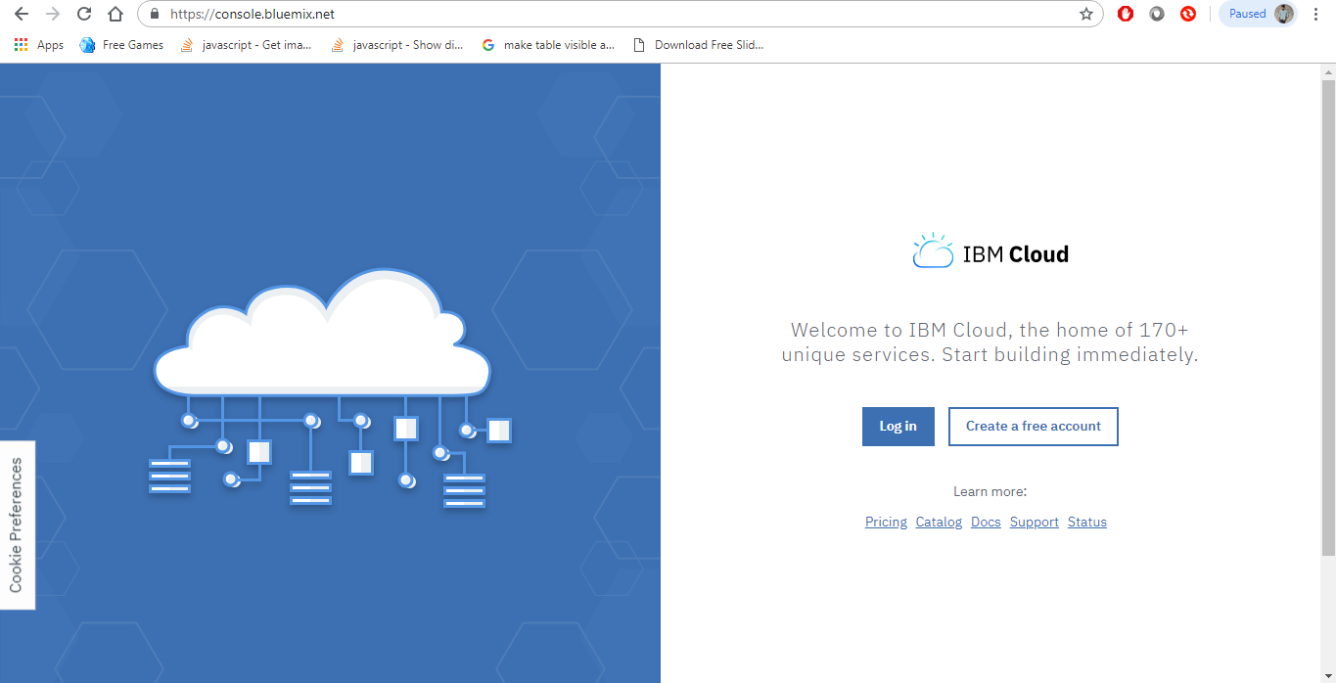

After signing in to the account. In the search box type node-RED

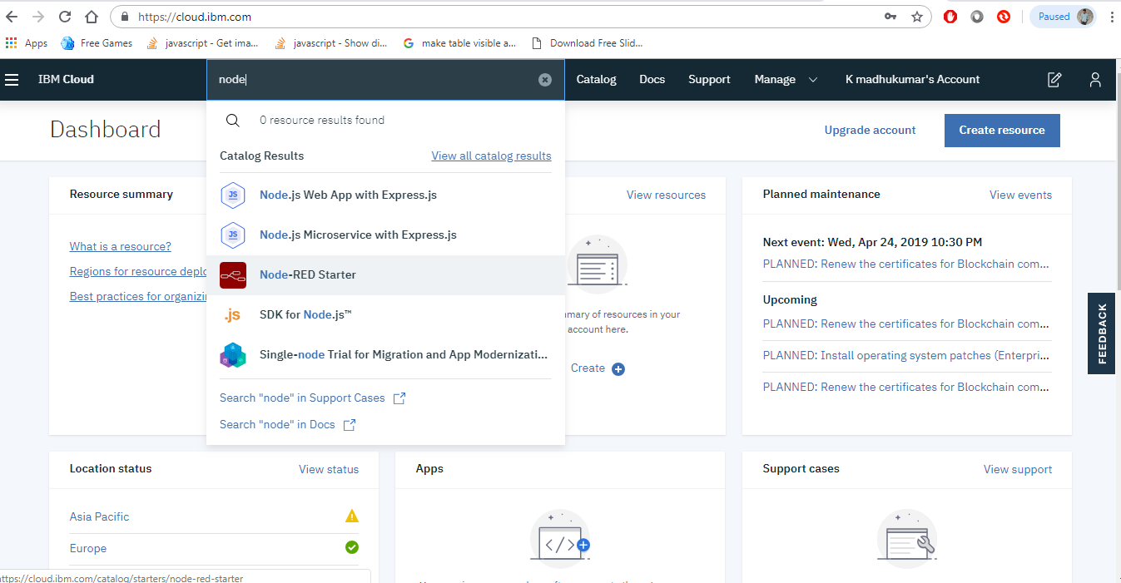

Then select the Node-RED starter from the list and fill the required fields and click on create as shown below

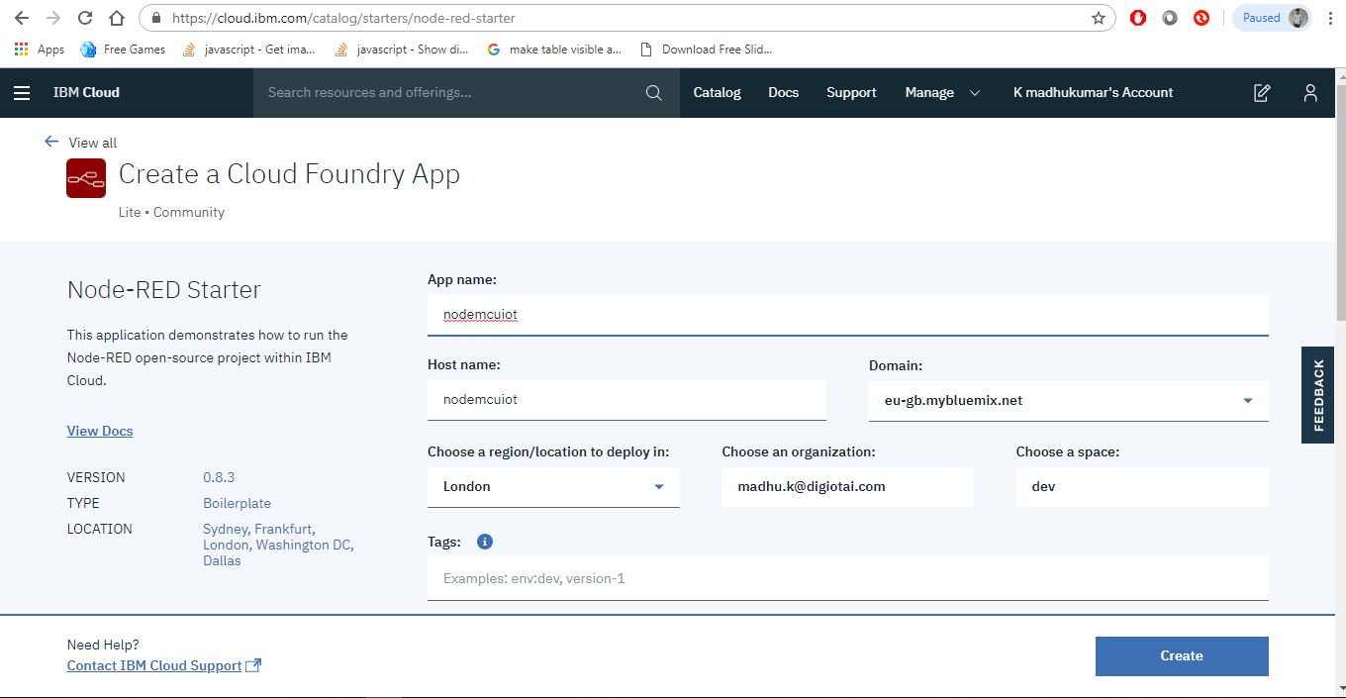

Then click on visit App URL as shown in below

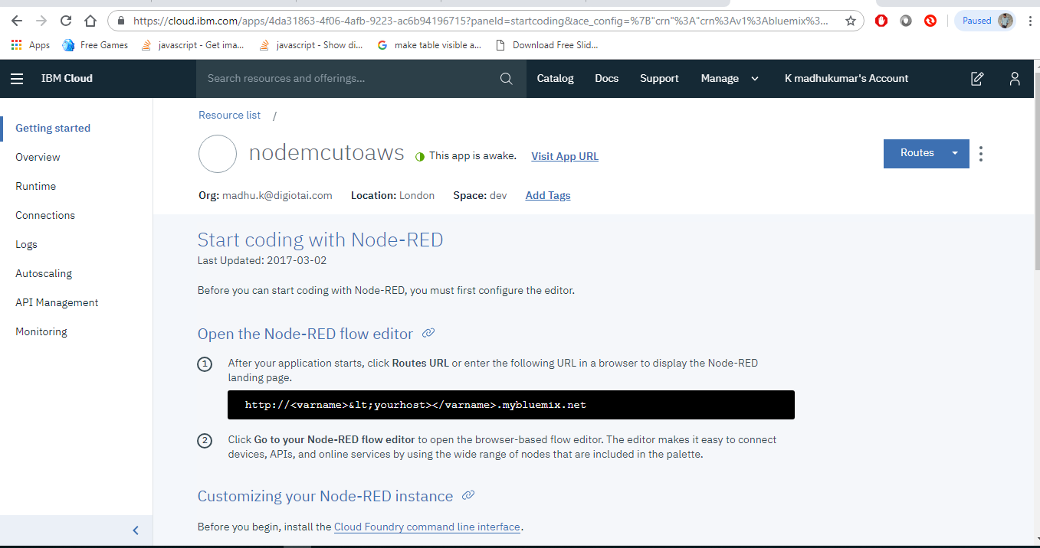

Then follow the steps and finish the process, then the following tab appears

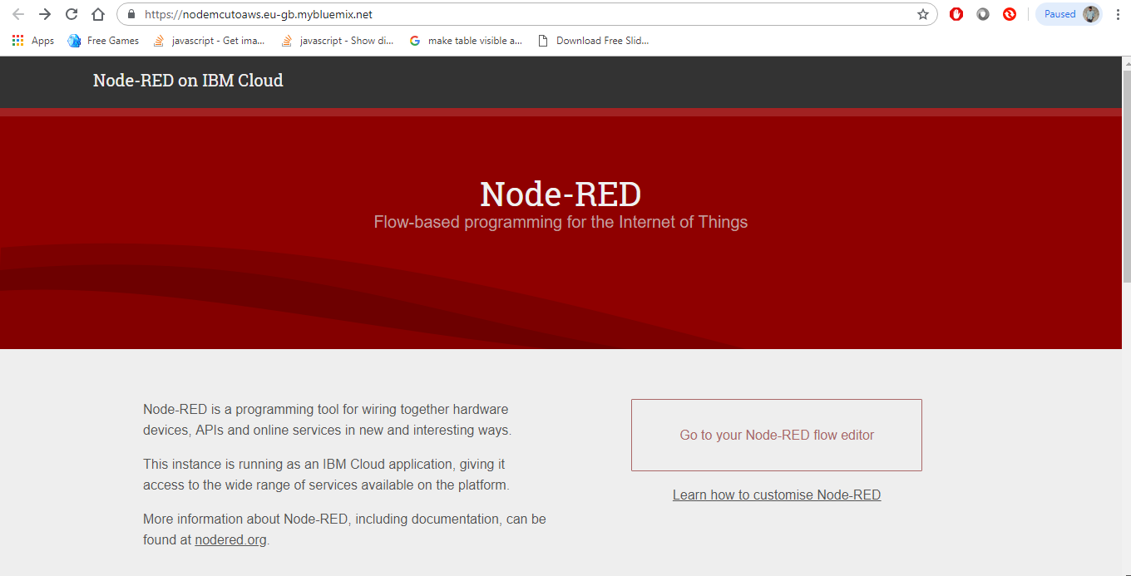

Now click on Go to your Node-RED flow editor

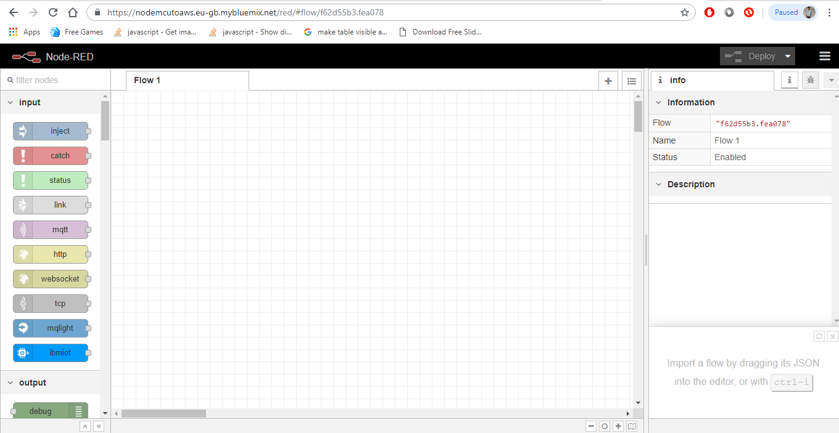

Then configure the connections as follow step by step:

Made the connections as shown in below

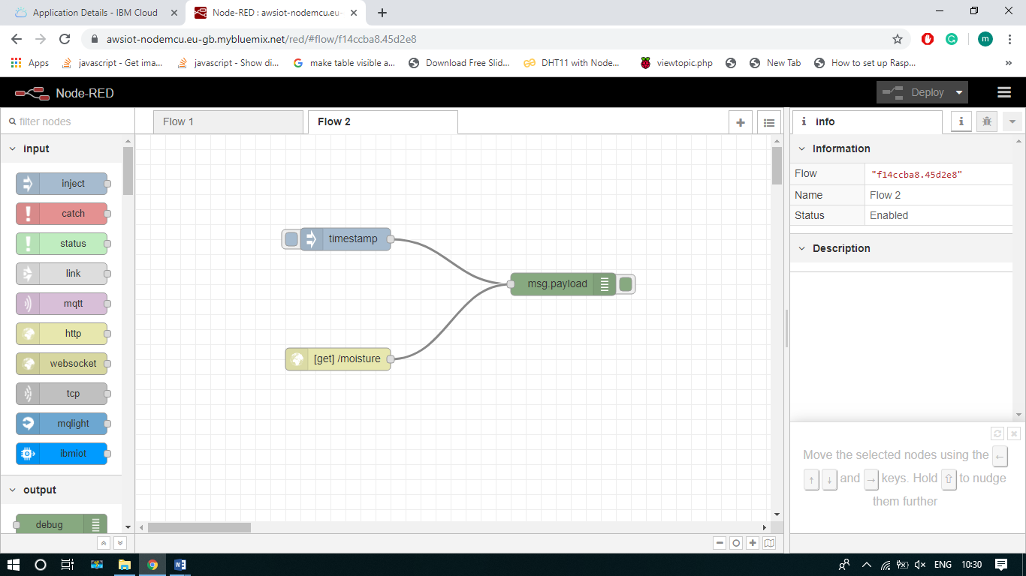

After completing the process don’t forget to click on Deploy Button.

Now paste the below code in Arduino IDE and compile it.

**#include <ESP8266WiFi.h>**

**const char WEBSITE[] = "awsiot-nodemcu.eu-gb.mybluemix.net"; //Static IP at Node Red do not use http or https prefix**

**const char* MY_SSID = "ACT FIBERNET";**

**const char* MY_PWD = "act12345";**

**void setup()**

**{**

**Serial.begin(115200);**

**// dht.begin();**

**Serial.print("Connecting to "+*MY_SSID);**

**WiFi.begin(MY_SSID, MY_PWD);**

**Serial.println("going into wl connect");**

**while (WiFi.status() != WL_CONNECTED) //not connected, ...waiting to connect**

**{**

**delay(1000);**

**Serial.print(".");**

**}**

**Serial.println("wl connected");**

**Serial.println("");**

**Serial.println("Credentials accepted! Connected to wifi\n ");**

**Serial.println("");**

**}**

**void loop() {**

**delay(3000);**

**// read the input on analog pin 0:**

**int sensorValue = analogRead(A0);**

**// Convert the analog reading (which goes from 0 - 1023) to a voltage (0 - 5V):**

**float voltage = sensorValue * (1000.0 / 1023.0);**

**// print out the value you read:**

**Serial.print("sensor value=");**

**Serial.print(voltage);**

**WiFiClient client; //Instantiate WiFi object, can scope from here or Globally**

**//Start or API service using our WiFi Client through PushingBox then relayed to Google**

**if (client.connect(WEBSITE, 80))**

**{**

**Serial.print(" Data sent to Node red \n");**

**//http URl format is ---> ?variable1=value&variable2=value2**

**client.print("GET /moisture?sensorvalue=" + (String)voltage**

**);**

**// HTTP 1.1 provides a persistent connection, allowing multiple requests to be batched**

**// or pipelined to an output buffer. Careful when altering headers, they arnt forgiving!**

**client.println(" HTTP/1.1");**

**client.print("Host: ");**

**client.println(WEBSITE);**

**client.println("User-Agent: ESP32/1.0");**

**client.println("Connection: close");**

**client.println();**

**}**

**}**

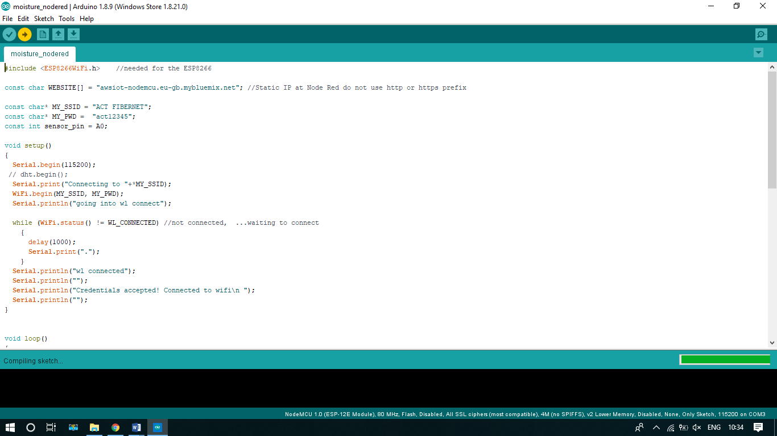

After compiling open the serial monitor & Node Red flow editor to check the values are updated as follows

